Role of Itopride in Minimizing Post-Prandial Glucose Excursion in Type 2 Diabetic Patients
Delayed gastric emptying is a frequent complication of Type 2 Diabetes Mellitus due to autonomic neuropathy, contributing significantly to post-prandial glucose (PPG) excursion and suboptimal glycemic control.
Conventional oral anti-diabetic therapy does not address impaired gastric motility and reduced incretin response—key mechanisms behind persistent post-prandial hyperglycemia.
This study evaluated whether addition of itopride, a prokinetic agent, to standard therapy could reduce post-prandial glucose excursion by enhancing gastric emptying and improving incretin-mediated insulin secretion
Study Design | Population | Center | Intervention | Key Outcome
Comparative, 12-month study (Jan–Dec 2012) | 100 Type 2 DM patients with symptoms of delayed gastric emptying (nausea, bloating, early satiety); 50 per group | Dept. of Medicine & Pharmacology, Khyber Teaching Hospital, Peshawar,Pakistan | Group I: OAD + Placebo; Group II: OAD + Itopride (pre-meal) | Mean PPG excursion reduced from 176.56 mg/dL (control) to 62.52 mg/dL (itopride)

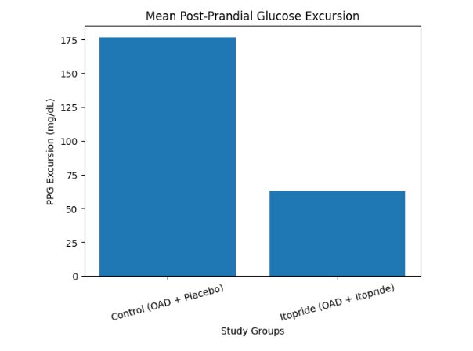
Conclusion
Addition of itopride to standard oral anti-diabetic therapy resulted in a marked reduction in post-prandial glucose excursion compared to control.
Improvement in gastric motility likely enhanced incretin response and early insulin secretion, addressing a key pathophysiological contributor to post-prandial hyperglycemia.
Itopride can serve as a rational adjunct in Type 2 diabetic patients with symptoms of delayed gastric emptying and inadequate post-prandial glycemic control.

